LAB REPORT
Experiment No.:06
Experiment Name: Reversing each word of an input text using stack
Code:
.MODEL
.STACK 100H
.DATA
msg_in DB "Enter a text: $"
msg_out DB 0AH,0DH,"Each word reversed: $"

.CODE
MAIN PROC
;init data
MOV AX,@DATA
MOV DS,AX

;prompt
MOV AH,9
LEA DX, msg_in
INT 21H

;input
XOR CX,CX
INPUT:
MOV AH,01
INT 21H
CMP AL,ODH
JE BR_INPUT
XOR AH,AH
PUSH AX
INC CX
JMP INPUT
BR_INPUT:
;check for empty input
CMP CX,0
JE PRINT

;process second stack
MOV BX,50H

REVERSE:
POP DX
XCHG BX,SP
PUSH DX
XCHG BX,SP
LOOP REVERSE

;print
PRINT:
MOV AH,9
LEA DX, msg_out
INT 21H

XCHG BX,SP
MOV AH,2

WHILE:
XOR CX,CX

WORD:
POP DX
CMP DX,20H
JE BR_WORD

XCHG BX,SP
PUSH DX
INC CX
XCHG BX,SP

JMP WORD

BR_WORD:

XCHG BX,SP

PRINT_WORD:
POP DX

INT 21H
LOOP PRINT_WORD

XCHG BX,SP

CMP SP,50H
JGE BR_WHILE

MOV DL,20H
INT 21H

JMP WHILE

BR_WHILE:

;exit
MOV AH,4CH
INT 21H

MAIN ENDP
END MAIN

Output:
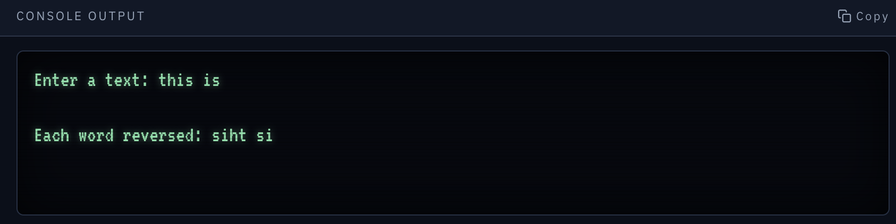
Discussion:
This program takes a line of text from the keyboard and reverses each word individually. At first, the characters are pushed into the stack. Later the reverse string is again pushed into the same stack but in other portion. For this we will get the correct order string. After this, we pop each character until we get “ ”, and the pop characters are pushed into 100h(first portion of the stack).Then we pop the first portion of the stack and print them in the screen. This continues until words are finished.

